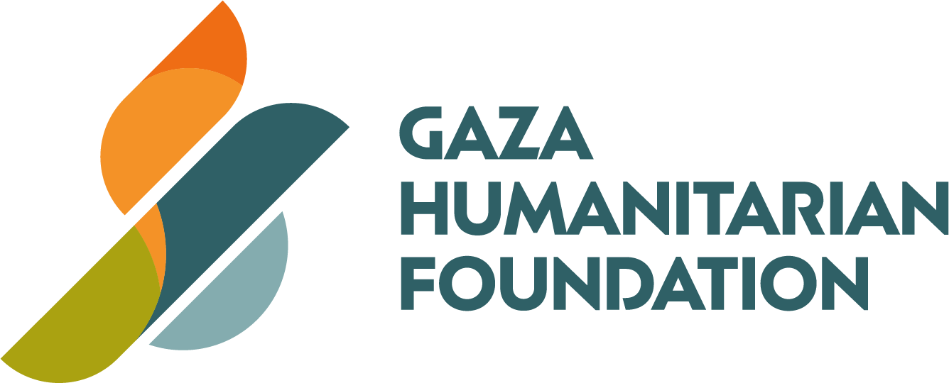

Gaza Humanitarian Foundation (GHF): Safe, Transparent Aid for Gaza

Why GHF, Why Now
Months of conflict have collapsed traditional relief channels in Gaza, leaving millions of civilians without reliable access to food, water, and other necessary supplies. Aid diversion, active combat, and restricted access have prevented life-saving assistance from reaching the people it is meant to serve and eroded donor confidence. GHF was established to restore that vital lifeline through an independent, rigorously-audited model that gets assistance directly— and only— to those in need.

A New Operating Model
GHF will initially stand up four Secure Distribution Sites (SDS), each built to continuously serve 300,000 people—1.2 million Gazans in the initial phase, with capacity to expand past 2 million. Pre-packaged rations, hygiene kits, and medical supplies move through tightly controlled corridors, monitored in real time to prevent diversion. At just US $1.3¹ per meal (including procurement, logistics, distribution and security), donors can see immediate, measurable impact.

Leadership & Governance
The foundation is led by seasoned crisis operators and fiduciaries:
- Board — Nate Mook (Former CEO, World Central Kitchen, Special Advisor on Ukraine to the Howard G Buffett Foundation) and other directors with extensive finance, audit and governance expertise.
- Executive Team — Jake Wood (Founder, Team Rubicon) as Executive Director; David Burke as COO; John Acree as Head of Mission.
- Advisory Board — humanitarian and security heavyweights such as former WFP chief Gov. David Beasley (to be finalized), ex-UN DRO (responsible for UN’s global security) Bill Miller, and LTG Mark Schwartz, former U.S. Security Coordinator for Israel/PA.
This mix of humanitarian, diplomatic, security, and financial expertise ensures both principled action and operational discipline. Major donors are invited to nominate additional candidates for Board membership.

¹ The cost breakdown is as follows: $0.58 per meal for commodity procurement and $0.67 for logistics, security, distribution, and other overheads. This structure is consistent with industry benchmarks - procurement generally ranges from $0.50 to $0.80 per meal, while 60–80 percent of total humanitarian-operation spending typically covers logistics and related costs..

Transparency & Accountability
GHF embeds third-party oversight at every layer: one of the world’s most respected audit and assurance firms is being retained for independent audits; One of world’s most prominent law firms will provide outside counsel on nonprofit and international compliance. Secure banking with Truist and J.P. Morgan, plus a Swiss affiliate backed by Goldman Sachs, gives donors multiple, globally trusted channels. Real-time monitoring and beneficiary feedback loop into public dashboards so every dollar is traceable and every outcome verifiable.

High-Impact Giving Paths
- Fund Meals – US $65 covers 50 complete meals in a family-box, delivered directly to an at-risk civilian.
- Donate Goods-in-Kind – Donate food, WASH, medical, or shelter items; GHF handles packaging, transport, and safe distribution.
- Partner via an Existing NGO – Support any NGO that routes its cargo through GHF; we secure movement from the Port of Ashdod or Kerem Shalom straight to the SDS.

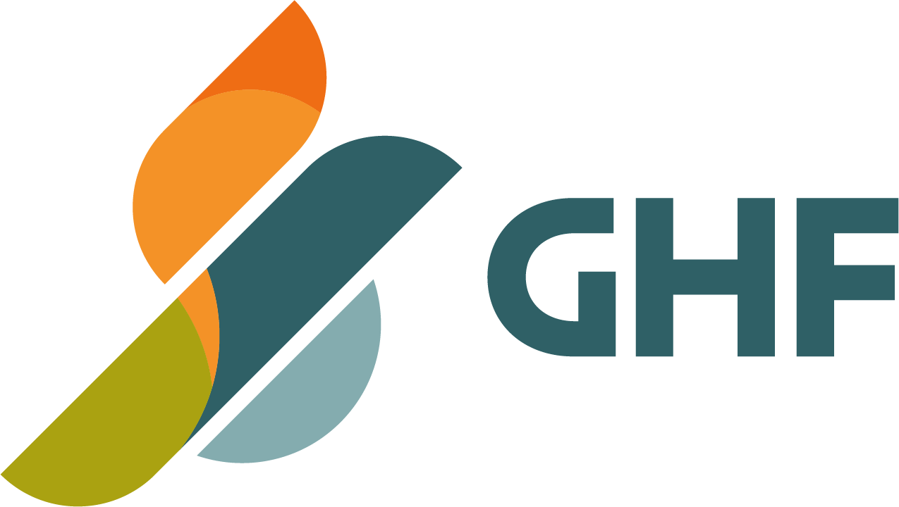
2

Gaza Humanitarian Foundation

Overview
The Gaza Humanitarian Foundation (GHF) coordinates a coalition that delivers essential aid directly to Palestinian civilians in Gaza with security, impartiality, and urgency. In a region defined by complexity, GHF offers a new approach based on independent operations, rigorous oversight, and experienced leadership drawn from humanitarian, diplomatic, and security fields.
GHF’s initial operations will support 1.2 million Gazans through four Secure Distribution Sites (SDS), each designed to continuously serve 300,000 people. These sites will provide food, water and hygiene kits (and potentially fuel) with plans to scale to reach over 2 million people across Gaza.
- Governance Structure
Board of Directors Provides strategic and fiduciary oversight, ensures mission fidelity, and evaluates executive performance.
Executive Team: Responsible for day-to-day operations, partner coordination, compliance, and reporting.
Advisory Board: Advises on compliance with humanitarian principles

Board of Directors (full bios in appendix):

  - Nate Mook – Former CEO of World Central Kitchen, Special Advisor on Ukraine to the Howard G Buffett Foundation
  - Raisa Sheynberg - Vice President, Government Affairs and Policy at Mastercard.
  - Former U.S. National Security Council Director for International Trade & Investment. Also worked as senior advisor at the Department of Treasury, Office of Terrorist Financing.
  - Jonathan Foster - Founder and Managing Director of Current Capital. Has been on the Board of over 50 companies and has been chair of two Fortune 500 Audit committees.
  - Loik Henderson – Lawyer with decades of experience to include Fortune 500 companies specializing in business structuring and governance.
Executive Leadership (full bios in appendix):

  - Jake Wood, Executive Director – Founder and former CEO of Team Rubicon, veteran of over 1500 disaster and humanitarian operations. Marine Corps veteran.
  - David Burke, Chief Operating Officer – Organizational strategy expert with experience growing humanitarian program delivery from zero to scale

3

  - John Acree, Head of Mission – Former USAID response leader; expert in field coordination across fragile states.
Advisory Board (full bios in appendix):

  - David Beasely - Former Governor of South Carolina. Former Executive Director of the United Nations World Food Programme (to be finalized).
  - Bill A. Miller – Former UN Director of Regional Operations responsible for the global security enterprise of the United Nations in the field. Former Director of the US Diplomatic Security Service; Expert in international security and crisis management.
  - LTG Mark C. Schwartz (Ret.) – Former U.S. Security Coordinator for Israel and the Palestinian Authority; senior military logistics and operations leader.
  - Additional Humanitarian luminaries, as well as prominent Palestinians are in discussion to join the GHF’s advisory board.

Our Mission, Vision and Values
GHF’s mission is to alleviate the suffering of Gaza’s civilian population by delivering life-saving aid safely, securely, and in strict adherence to humanitarian principles—ensuring assistance reaches those most in need, without diversion or delay.
GHF’s vision is a Gaza where every person in need has unimpeded access to the food, shelter, and care they need to live with dignity.

Values:

  - Humanity First
We exist to alleviate suffering. Every decision, every action, and every dollar is driven by our unwavering commitment to the dignity and survival of people in crisis.

Safe Access, Real Impact
By building secure delivery systems, we ensure aid reaches those most at risk, not those with the most power.

Adaptive Innovation
In a volatile environment, we stay principled and flexible—protecting our mission while adapting to shifting realities on the ground.

Compounding Collaboration
We work with all who are willing to partner together to pursue pragmatic approaches to intractable problems.

4

Our Commitment to Humanitarian Principles
At GHF, humanitarian principles are not ideals—they are at the core of our operations. We are driven by a commitment to saving lives, protecting dignity, and delivering hope in the world’s most complex and dangerous environments.
We are guided by the humanitarian principles of humanity, neutrality, impartiality, and independence. These values are not abstract; they shape every decision we make and every action we take.
We serve people based solely on necessity, without discrimination or bias. Our only allegiance is to those suffering and in need, regardless of their identity or circumstance. While we don't take sides, we pragmatically coordinate our operations with all parties to avoid conflict, minimize loss, and maximize impact.
This commitment lives not just in our words, but in our work—in every warehouse we build, every truck we dispatch, and every life we strive to protect.

GHF Impact Framework

Problem:

Civilians in Gaza are enduring extreme deprivation. Traditional humanitarian channels have collapsed under the weight of ongoing combat operations, systemic aid diversion, and restricted access. As a result, much of aid fails to reach the people it is intended to help, fueling despair and instability.

Context & External Factors:

  - Combat Operations: Active hostilities complicate aid delivery, movement, and site security.
  - Hamas and criminal organizations: Continue to intercept, tax, and resell aid, undermining humanitarian neutrality.
  - Israeli Politics: Domestic security concerns and political pressure limit Gaza access and drive risk-averse policy toward humanitarian organizations.
  - International Perception: Donor confidence is eroding due to a lack of transparency and persistent diversion.

Assumptions:

  - Civilians require humanitarian aid that is accessible, secure, and reliably stocked.
  - Israeli authorities will allow limited, deconflicted humanitarian corridors.
  - A non-governmental, politically neutral model can win trust across parties.
  - Donors will support new models if transparency and effectiveness are demonstrated.

5

Inputs:

  - Secure logistics, procurement, and site operations via trusted third-parties
  - International donor funding (GCC, EU, others)
  - Coordination with IDF/COGAT for access and deconfliction
  - NGO engagement for service provision
  - Technology for real-time tracking and reporting
  - Governance and audit frameworks to ensure compliance and accountability

Activities:

  - Set up and operate safe, neutral aid distribution sites (SDS)
  - Provide pre-packaged aid (food, shelter, hygiene, medical) directly to civilians
  - Collect data on aid delivery, access, and recipient feedback
  - Monitor and report on outcomes in real-time to funders and stakeholders

Outputs:

  - Civilians access aid safely without interference
  - Aid is delivered transparently and securely across multiple Gaza locations
  - Increased quantity and frequency of aid being made available to civilians
  - Ongoing reporting of delivery metrics, compliance, and site conditions

Outcomes:

  - Increased civilian health and decreased reliance on black-market aid
  - Reinforced neutrality and operational independence of humanitarian organizations
  - Rebuilt donor confidence through measurable, audited results
  - Pressure on all parties to respect humanitarian norms

Impact:

A functioning humanitarian lifeline in Gaza that mitigates suffering, upholds international humanitarian law, and demonstrates a scalable model for aid delivery in complex environments.

Near-term Operational Plan
The Gaza Humanitarian Foundation (GHF) is building a safe and scalable operational model to meet the urgent needs of Gaza’s civilian population while laying the groundwork for long-term community resilience.
GHF will set up modular, scalable Secure Distribution Sites (SDS) across Gaza. Over time, each SDS will be capable of serving up to 300,000 individuals, providing essential aid such as
pre-packaged food rations, potable water, hygiene kits, blankets, and other necessary

6

humanitarian supplies. These Sites are designed for flexibility, allowing for rapid expansion or adaptation based on shifting needs and on-the-ground developments.
To ensure the integrity and safety of aid delivery, GHF’s logistics subcontractors will utilize armored vehicles to transport supplies to and from SDS locations. On-site and perimeter security will be provided by experienced professionals, including personnel who previously secured the Netzarim Corridor during the recent ceasefire. Their mandate is to deter interference from criminal networks or other armed groups who have historically sought to control or redirect humanitarian aid. Importantly, the Israeli Defense Forces (IDF) will not be stationed at or near SDS locations, maintaining the neutral and civilian-facing nature of operations.
Aid will be distributed without regard to identity, origin, or affiliation. There will be no eligibility requirements—assistance will be delivered purely based on need, with community dignity and safety as top priorities.
To expand reach and increase efficiency, GHF seeks to partner with NGOs, UN agencies, and civil society organizations to facilitate the movement and distribution of their aid through GHF’s secure distribution infrastructure. These partnerships will allow humanitarian organizations of all sizes to take advantage of GHF’s logistics, security, and transparency frameworks—ensuring their aid reaches intended beneficiaries without diversion or delay. By serving as a trusted logistics partner, GHF offers operational capacity and neutrality that complements the missions of established aid providers.
GHF recognizes that security is not just physical—it is also social. GHF and its partners are actively engaging local communities to generate support for GHF operations and ensure the safety of its facilities and staff. These champions serve as cultural and logistical bridges, helping to secure
buy-in, facilitate aid distribution, and create a protective local environment for humanitarian efforts.
Over time, GHF will train and employ additional local champions, allowing aid operations to expand deeper into underserved areas. This effort aims not only to safeguard humanitarian access, but to ethically empower traditional community leaders to reestablish constructive influence supporting the organic restoration of local communities
As SDS operations stabilize, they can become hubs for additional NGOs and local communities who wish to co-locate near them. In such an event, GHF will explore the possibility of offering safe lodging, showers, restrooms, and operating spaces for NGOs in order to expand the portfolio of services offered to the local population beyond immediate relief.
By combining physical security, community leadership, NGO collaboration, and non-aligned operations, GHF offers a resilient, adaptable model for aid delivery—one that serves the people of Gaza directly.

7

Our Commitment to Transparency and Accountability
At GHF, we believe that effectiveness must be measured—not assumed. That’s why we will embed rigorous Monitoring and Evaluation (M&E) frameworks into every program we operate. These systems will track both what we deliver and the impact it has, ensuring our efforts are driven by data, not assumptions. We will collect real-time feedback from beneficiaries, monitor outcomes against clear performance indicators, and use this data to continually refine and improve our operations.
To complement this internal rigor, we are in the process of retaining one of the world’s most respected audit and assurance firms, to provide independent third-party oversight of our financial and operational practices. Their involvement will ensure every dollar is traceable, every process auditable, and every outcome verifiable. We are also having a discussion with Deloitte as well.
This two-tiered approach—robust internal evaluation paired with independent external validation—will reflect our deep commitment to transparency and accountability. We won’t just report our results—we will prove them.

Legal General Counsel

GHF is proud to be in discussions with one of the world’s prominent law-firms to serve as our Outside Counsel (engagement underway but not yet finalized). The firm has deep expertise in international law, nonprofit governance, and humanitarian compliance.
The firm will help GHF establish a world-class legal foundation—ensuring that our operations, contracts, partnerships, and compliance protocols meet the highest ethical and legal standards. Their counsel strengthens our ability to act with integrity, transparency, and accountability at every level of our mission.

Financial Infrastructure

GHF maintains secure banking and financial relationships with Truist Bank and JP Morgan Chase, two of the most respected financial institutions in the world. These banks were not selected by chance—they were chosen deliberately for their stellar reputations, global footprints, and longstanding history of integrity and stability.
Truist has demonstrated its commitment to humanitarian and disaster relief efforts, notably committing $725 million toward recovery initiatives in Western North Carolina following Hurricane Helene. Through its Truist Foundation, the bank also partnered with the Center for Disaster Philanthropy to provide over $20 million in grants supporting medium- and long-term disaster recovery.
JPMorgan Chase has responded to major crises around the world, including a $10 million philanthropic commitment to support displaced civilians during the Ukraine crisis, offering

8

temporary shelter and emergency aid. Their global operations and flexible funding strategies allow for timely responses in high-stakes environments—making them a natural fit for the scale and ambition of GHF.
We understand that effective humanitarian response demands not only speed and flexibility, but also ironclad financial accountability. Working with Truist and JP Morgan ensures our funds are handled by institutions that are trusted worldwide and have the infrastructure necessary to support our complex, multinational financial operations. Their global networks, advanced compliance systems, and robust security protocols allow GHF to manage donor contributions with confidence and precision.
As with every element of GHF, our choice of financial partners reflects our unwavering commitment to excellence. When lives are on the line, only the best will do.

Swiss GHF

The GHF is also in the process of establishing a Switzerland based affiliate to address donors who would prefer to participate outside of the U.S. structure. The Swiss GHF Board and Executive team will closely mirror that of the U.S. GHF and will adhere to the same principles, mission and values detailed above. The Swiss GHF has a verbal commitment from Goldman Sachs to establish a bank account for this affiliate which should be completed shortly.

How You Can Help - High-impact Giving Options That Gets to Those Who Need It

Giving Path | What Your Support Does | Example Contribution
1. Fund Meals | Covers procurement, security, logistics, and on‑site distribution of ready‑to‑eat rations. | US $65 covers 50 complete meals in a family-box, delivered directly to an at-risk civilian - reflecting a  US $1.3 cost per 1 750 kcal meal² (including food,  end-to-end logistics and  security).

² The cost breakdown is as follows: $0.58 per meal for commodity procurement and $0.67 for logistics, security, distribution, and other overheads. This structure is consistent with industry benchmarks - procurement generally ranges from $0.50 to $0.80 per meal, while 60–80 percent of total humanitarian-operation spending typically covers logistics and related costs.

9

2. Donate Goods‑in‑Kind | Ship food, medical, shelter, or WASH supplies; GHF packages, transports, and distributes them securely. | Container of fortified rice or flower.
3. Partner via an Existing NGO | Fund an NGO of your choice that commits to route its aid through GHF. We handle logistics from Port of Ashdod—or secure entry at Kerem Shalom if the NGO ships directly to the SDS.

Conclusion
The Gaza Humanitarian Foundation represents a pragmatic model of humanitarian engagement in the face of unprecedented suffering—one rooted in reality, built on transparency, and led by sector experts. With an experienced team, rigorous infrastructure, and an unyielding commitment to human dignity, GHF is ready to meet today’s need while shaping tomorrow’s potential.
Appendix - Full Leadership Bios

Board of Directors

Nate Mook
Nate Mook is a globally recognized leader in humanitarian innovation and emergency response, with deep experience building agile, scalable operations in high-risk environments. As the CEO of World Central Kitchen (WCK), Nate transformed the organization from a grassroots food relief effort into a globally deployed, logistics-driven disaster response NGO. Under his leadership, WCK scaled to over 60 countries, delivering more than 60 million meals in response to hurricanes, earthquakes, refugee crises, and conflict zones—often outpacing larger organizations due to its operational speed and community-first model.
Mr. Mook led field operations across the Caribbean, South America, Eastern Europe, and
Sub-Saharan Africa, personally deploying to the frontlines of crises ranging from Hurricane Dorian in the Bahamas to Russia’s invasion of Ukraine. Nate pioneered WCK’s “food first responder” approach, blending private-sector logistics, chef-led kitchens, and community mobilization.
Beyond operations, Nate is a passionate communicator and advocate. A filmmaker by training, he produced documentaries and storytelling campaigns for the UN, World Bank, and USAID, using media to galvanize public engagement and funder support. His unique skill set—storytelling, rapid

10

operations, coalition-building—makes him an invaluable board member, ensuring GHF remains nimble, people-centered, and globally visible.

Loik Henderson
Loik Henderson, Esq. is a legal and business professional with over 20 years of experience in private practice and in-house roles, to include Fortune 500 companies. Mr. Henderson specializes in complex transactional matters, business structuring and governance, particularly in highly regulated environments, and has worked across a variety of industries, including healthcare, IT, telecommunications, and the public sector. Mr. Henderson holds both Juris Doctor (JD) and Master of Business Administration (MBA) degrees.

Raisa Sheynberg
Raisa’s work focuses on policy and regulatory issues pertaining to digital assets. Before joining the original Libra public policy team at Facebook to work on blockchain policy, she spent a decade working on national security and economic policy with the U.S. federal government. Raisa worked in the office of Terrorism and Financial Intelligence at the Treasury Department and at the U.S. National Security Council as the Director for International Trade and Investment. Her policy experience includes work on illicit finance and sanctions, AML/CFT, international trade, and market access. She helped advance policy initiatives such as the Trans-Pacific Partnership trade agreement and international engagement around norms of conduct in cyberspace and cybersecurity. Raisa worked to build strategic partnerships on behalf of the U.S. government across the Middle East, in Mexico and Russia. Since leaving the federal government Raisa worked with small and large technology companies and major American multinationals on high-profile global policy challenges and strategic communications.

Jonathan Foster
Jonathan F. Foster is the Founder and a Managing Director of Current Capital Partners LLC, a mergers and acquisitions advisory, corporate management services and private equity investing firm. Jon spent a decade at Lazard, primarily focused on mergers and acquisitions advisory work, ultimately as a Managing Director. He has been on more than 50 boards, including Fortune 500 companies, private companies and companies involved in restructurings. Foster has served as chair, lead director and on the three major board committees as well as special, transaction and CEO succession committees. He has been chair of two Fortune 500 Audit committees. He has also been an expert witness in corporate litigation for some 60 cases. With decades of experience, Foster has written, spoken and been quoted frequently about governance and finance topics and has guest lectured at various universities. Jon lives in New York City with his wife and goldendoodle; he has two adult children.

Executive Leadership

11

Jake Wood - Executive Director
Jake Wood is a decorated Marine Corps veteran, award-winning social entrepreneur, and globally recognized expert in crisis leadership. As the co-founder and longtime CEO of Team Rubicon, Jake led the organization from concept to a nonprofit with 180,000+ veteran volunteers, redefining what post-military service could look like. He pioneered the integration of military veterans into humanitarian roles, creating a scalable model of disaster response that bridged public, private, and nonprofit sectors.
Team Rubicon has executed over 1,300 deployments—from Haiti’s earthquake and Puerto Rico’s hurricane recovery to wildfire containment and COVID-19 response..
He is also the founder of Groundswell, a venture-backed SaaS platform reinventing employee giving through donor-advised funds. Through his ventures, Jake has raised over $400 million in philanthropic and venture capital. His published memoir, Once A Warrior, and regular media appearances have made him an influential voice in national conversations around leadership, resilience, and impact. At GHF, Jake sets the strategic vision and leads all operational execution, funder engagement, and interagency coordination.

John Acree - Head of Mission
John Acree is a senior humanitarian practitioner with more than two decades of global field experience in disaster response, stabilization programming, and civil-military coordination. He has served as Chief of Party on U.S. government contracts valued at over $45 million, with oversight across 30+ countries in Latin America and the Caribbean. His operational expertise spans refugee assistance, supply chain coordination, post-disaster recovery, and political transition support.
John spent a significant portion of his career with USAID’s Office of U.S. Foreign Disaster Assistance (OFDA), including deployments to conflict-affected regions as part of Disaster Assistance Response Teams (DART). He has coordinated logistics and relief operations during complex emergencies—including active war zones and natural disasters—working closely with host governments, UN agencies, and local NGOs.
He holds a Master’s in International Public Administration and a Bachelor’s in Journalism and Media Studies, a combination that has enabled him to craft high-impact programs while communicating effectively with stakeholders from Capitol Hill to camp clinics. At GHF, he is responsible for designing and implementing the Secure Distribution Site (SDS) model, managing field teams, and building operational partnerships to ensure aid reaches beneficiaries swiftly and safely.

David Burke - Chief Operating Officer

12

David Burke is a strategic operations expert with a distinguished background in nonprofit management and organizational scale. A Marine Corps veteran, David joined Team Rubicon in its early stages and played a pivotal role in its rise as one of the world’s most innovative disaster response NGOs. As its Chief Programs Officer, he led a cross-functional team responsible for program delivery to more than 1.7 million beneficiaries across dozens of domestic and international crises.
David’s expertise spans budget management, operational compliance, organizational design, and performance measurement. He built and oversaw complex M&E systems, streamlined logistics workflows, and developed governance frameworks that enabled rapid growth without compromising control. During his tenure, he helped the organization scale to over $50 million in revenue and sustain best-in-class donor reporting and audit results.
In addition to his operational acumen, David has served on nonprofit boards and advised emerging NGOs on governance, scaling, and compliance. At GHF, he is responsible for building and overseeing all internal systems, including finance, human resources, procurement, and information security. His mandate is to ensure that GHF’s mission is executed through disciplined operations, measurable outcomes, and ironclad accountability.

Advisory Board

Bill A. Miller
Bill Miller brings over 35 years of experience leading international security operations for both the United Nations and the U.S. Department of State. As the UN’s Director of Regional Operations, he oversaw the global security apparatus that protected personnel, assets, and operations across every continent, including high-threat conflict zones. His portfolio included field security strategy, crisis management, and operational deconfliction between NGOs, peacekeeping missions, and host governments.
Prior to the UN, Mr. Miller served as the top civilian law enforcement officer for the U.S. diplomatic corps. He held critical assignments in Iraq, Pakistan, the Philippines, and Egypt, where he oversaw emergency evacuations, counterterrorism operations, and protection for high-level officials. His leadership during the Arab Spring in Cairo and his tenure as Regional Security Officer in Jerusalem underscore his ability to manage operational risk in the Middle East under intense geopolitical pressure.
A former U.S. Marine Infantry Officer and Senior Foreign Service member, Mr. Miller is a recipient of the Department of State’s Award for Valor, among numerous other recognitions. His depth of experience ensures that GHF’s operations are built upon proven frameworks for safety, legal compliance, and ethical conduct, even in non-permissive environments.

13

Lieutenant General Mark C. Schwartz (Ret.)
Lieutenant General (Ret.) Mark C. Schwartz brings over 30 years of U.S. Army experience and is one of the most respected American military leaders to have operated in the Israeli-Palestinian context. Most recently, he served as the U.S. Security Coordinator (USSC) for Israel and the Palestinian Authority—a role that required exceptional diplomacy, coalition management, and strategic acumen. In that capacity, LTG Schwartz led multilateral security efforts in a politically sensitive and operationally complex theater, working directly with IDF, Palestinian security forces,
U.S. State Department officials, and regional actors.

Previously, as Commander of the Combined Security Transition Command – Afghanistan, Schwartz managed the multibillion-dollar effort to train and sustain the Afghan security forces. His responsibilities included procurement, infrastructure development, and high-volume logistics in a warzone—directly applicable to the scale and scope of humanitarian aid operations GHF is undertaking.
He also served in NATO leadership, joint U.S. commands, and theater-level planning positions, where he honed his expertise in interagency coordination and civilian-military integration. LTG Schwartz holds advanced degrees in finance and strategy from Idaho State University and the Naval War College. At GHF, his role is to ensure operational discipline, effective intergovernmental coordination, and principled execution amid uncertainty.

David Beasley (to be finalized)
Former Governor of South Carolina, Mr. Beasley recently served as the Executive Director of the World Food Programme (WFP), having been nominated by two President’s Administrations of two different parties and appointed to that role initially in 2017 by the UN Secretary-General of the United Nations and served until April 2023.
Under Mr. Beasley’s leadership, WFP was the largest humanitarian organization in the world assisting over 160 million people in 2022 alone and raising over $55 billion USD.
In 2020, Mr. Beasley received the Nobel Peace Prize on behalf of WFP for its efforts to provide food assistance in conflict areas and to prevent food from being used as a weapon of war and conflict. In his acceptance speech delivered in Oslo on December 10, 2021, Mr. Beasley stated that “Working with 115 million people in 80 countries, day-in and day-out, the women and men of WFP have gained a unique perspective. We have learned that there is great richness in those who are seen, in the eyes of the world, as “the poor.” And many of us who are considered “rich” are actually poor in the things that matter most.” Mr. Beasley also received the John F. Kennedy Profiles in Courage Award for his stand on the Confederate Flag as well as many other awards. He majored in Microbiology at Clemson University and received a Doctor of Jurisprudence degree from the University of South Carolina. He also was a Fellow and taught at the Harvard University Kennedy School of Government. He is married to the former Mary Wood Payne and is the father of four children and three grandchildren.

14

